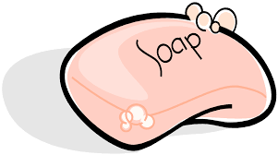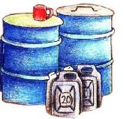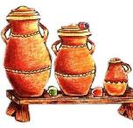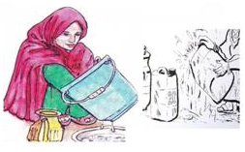

**Step 3**: Store water in clean covered containers to avoid contamination by flies and dust

**Step 2**: Use containers with lids/covers for fetching water

**Step 1**: WASH your Container before fetching water. Dirty containers will contaminate your water for drinking

**Steps for keeping water safe**

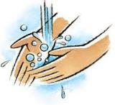

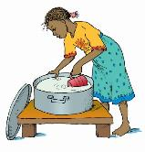

**Step 5**: WASH your hands with soap and Water to prevent transfer of germ- causing illnesses

**Step 4**: Avoid dipping your hand inside the water use a clean water dipper

